TCS NQT QUESTIONS

TABLE OF CONTENTS

SECTION 1 — EASY

SECTION 2 — BASIC-MEDIUM

SECTION 3 — MEDIUM

SECTION 1 — EASY

Grammar and Usage

Question 5
Exam: TCS NQT | Difficulty: Easy
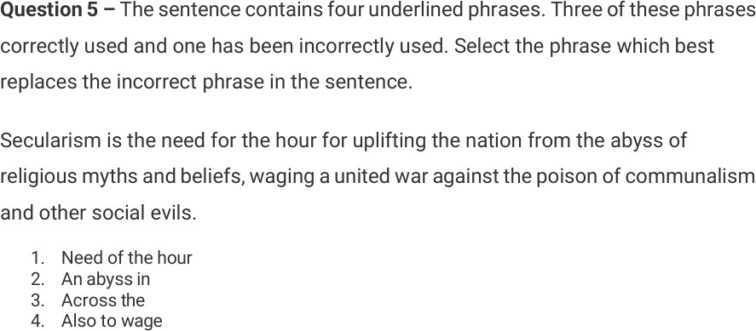

Letter Cluster

Question 1
Exam: TCS NQT | Difficulty: Easy

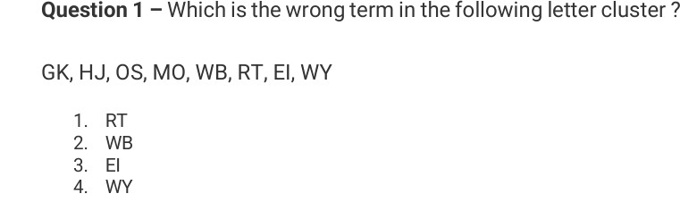

Mensuration

Question 2
Exam: TCS NQT | Difficulty: Easy
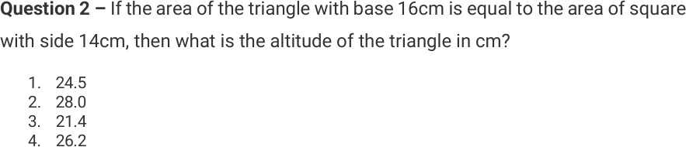

Percentage Distribution

Question 13
Exam: TCS NQT | Difficulty: Easy

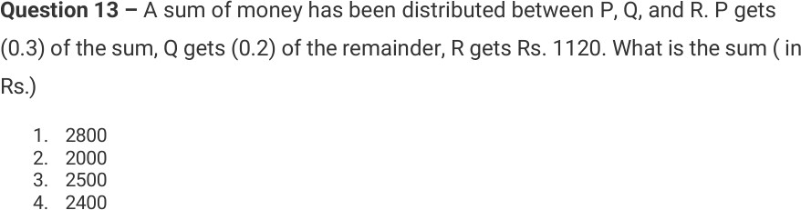

Ratio and Salary

Question 10
Exam: TCS NQT | Difficulty: Easy
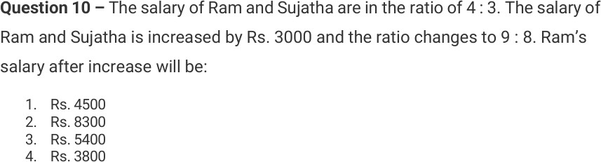

Sentence Completion

Question 11
Exam: TCS NQT | Difficulty: Easy
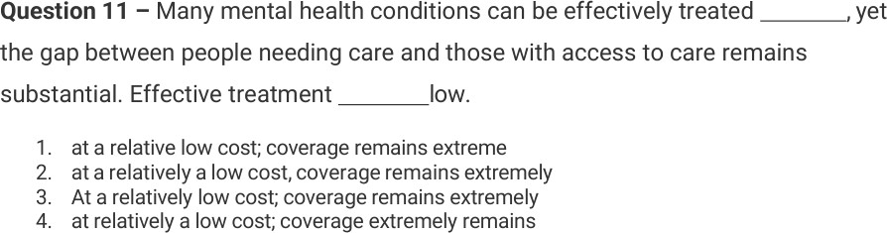

Vocabulary and Context

Question 5
Exam: TCS NQT | Difficulty: Easy

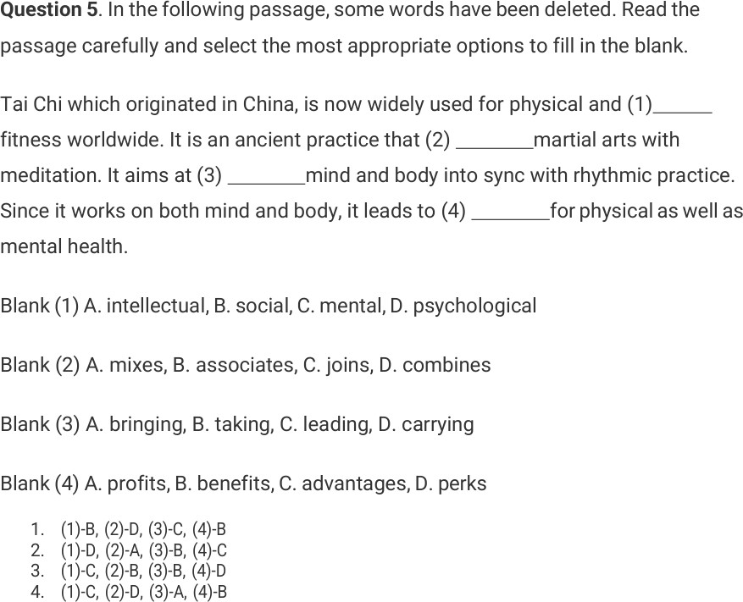

SECTION 2 — BASIC-MEDIUM

Average

Question 3
Exam: TCS NQT | Difficulty: Basic-Medium
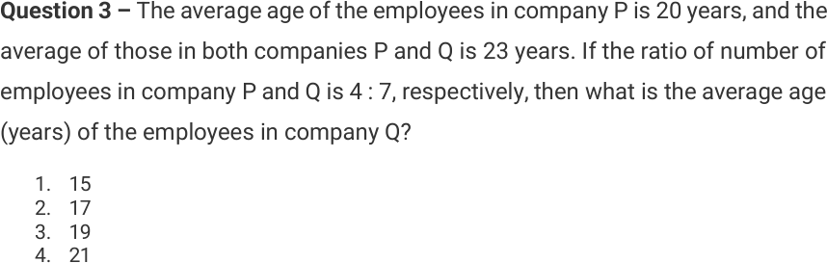

Average Speed

Question 15
Exam: TCS NQT | Difficulty: Basic-Medium
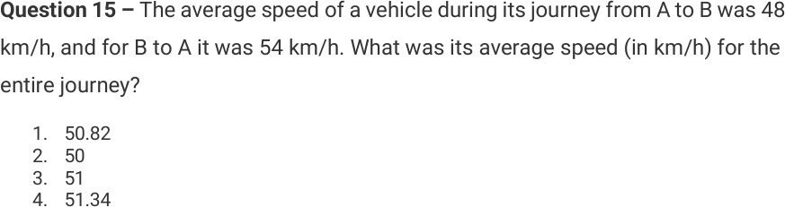

Blood Relation / Coding

Question 3
Exam: TCS NQT | Difficulty: Basic-Medium

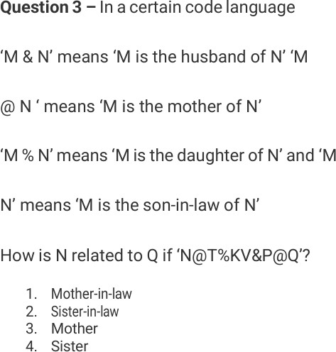

Data Sufficiency

Question 4
Exam: TCS NQT | Difficulty: Basic-Medium

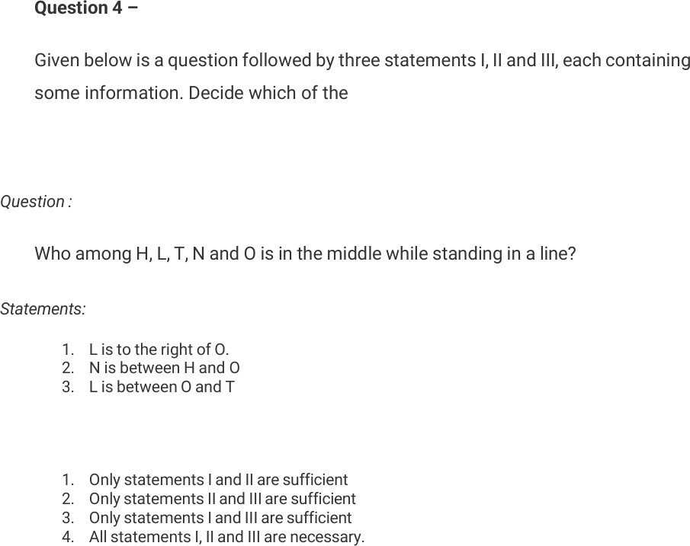

Question 4
Exam: TCS NQT | Difficulty: Basic-Medium

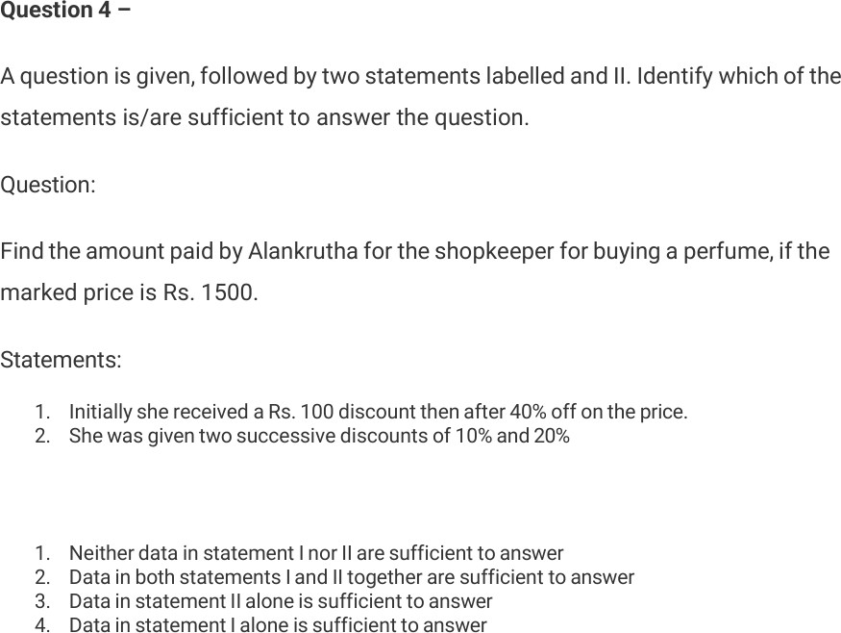

Idioms and Context

Question 6
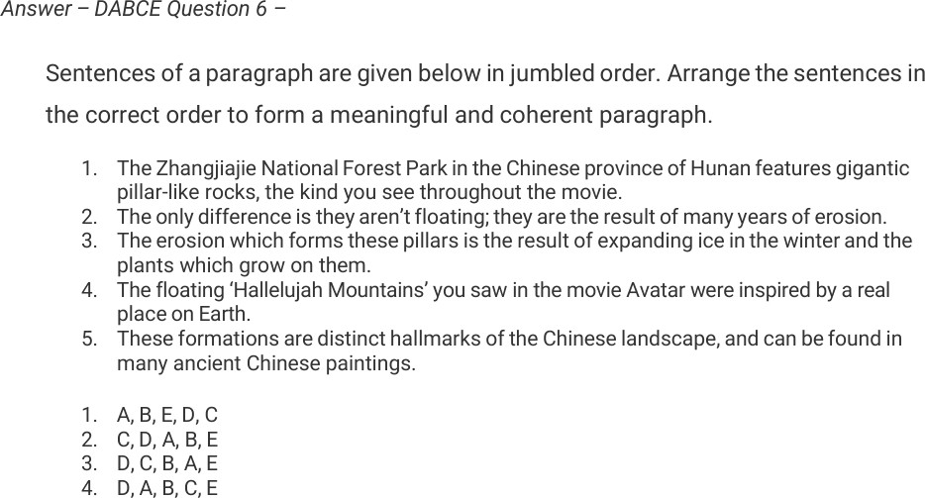
Exam: TCS NQT | Difficulty: Basic-Medium

LCM and HCF

Question 10
Exam: TCS NQT | Difficulty: Basic-Medium

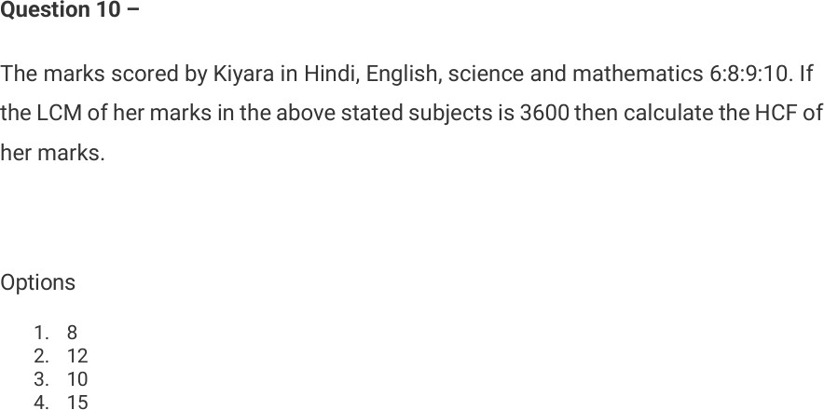

LCM and Time Intervals

Question 1
Exam: TCS NQT | Difficulty: Basic-Medium
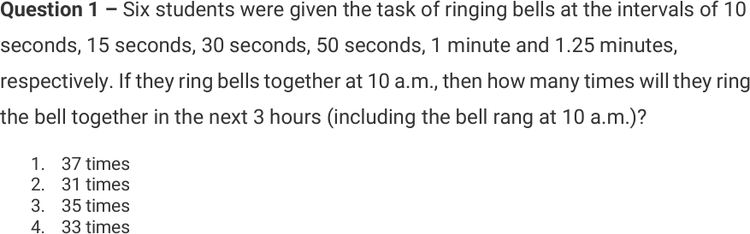

Letter Cluster

Question 2
Exam: TCS NQT | Difficulty: Basic-Medium

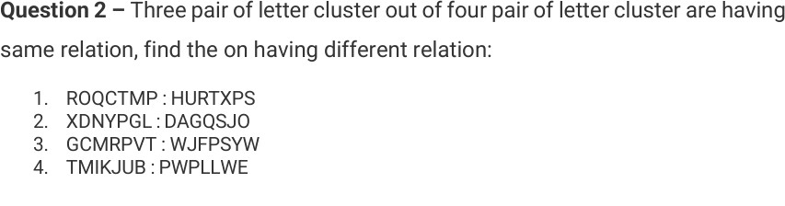

Percentage and Marks

Question 4
Exam: TCS NQT | Difficulty: Basic-Medium

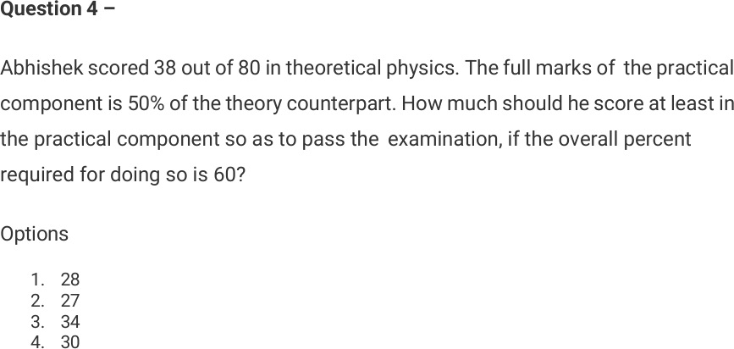

Profit and Loss

Question 6
Exam: TCS NQT | Difficulty: Basic-Medium
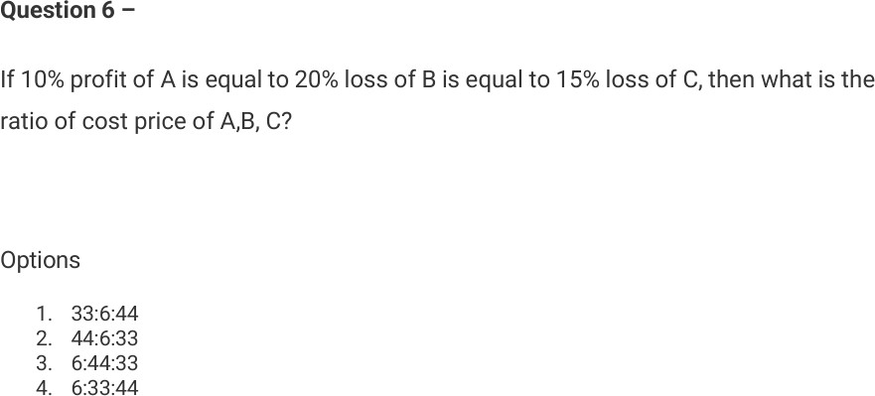

Ratio and Average

Question 3
Exam: TCS NQT | Difficulty: Basic-Medium
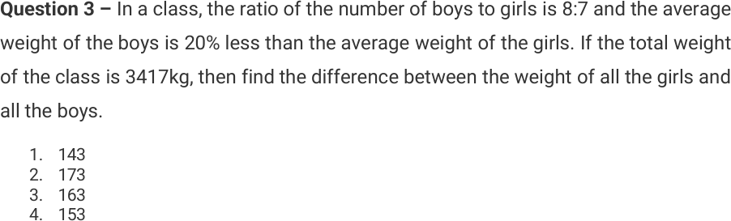

Sentence Arrangement

Question 11
Exam: TCS NQT | Difficulty: Basic-Medium

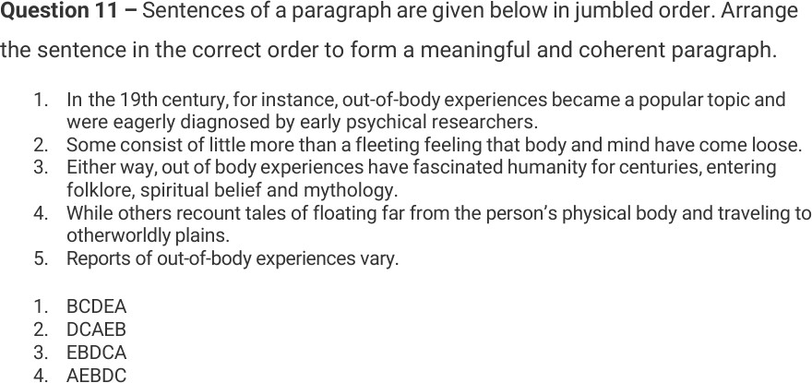

Question 11
Exam: TCS NQT | Difficulty: Basic-Medium
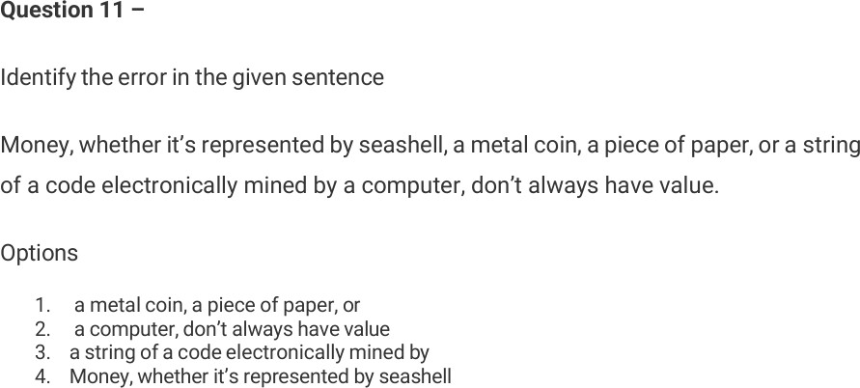

Simple Interest

Question 7
Exam: TCS NQT | Difficulty: Basic-Medium

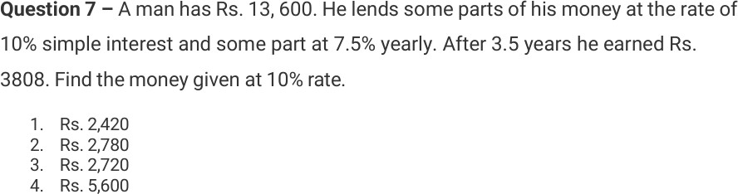

Question 6
Exam: TCS NQT | Difficulty: Basic-Medium
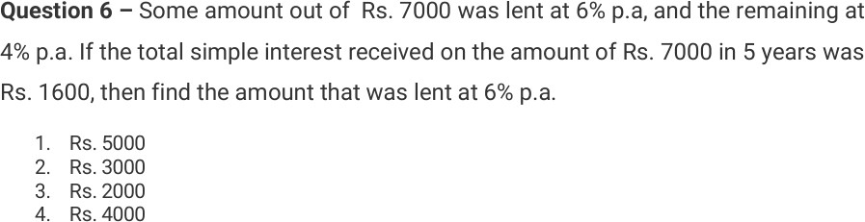

Speed, Time and Ratio

Question 7
Exam: TCS NQT | Difficulty: Basic-Medium
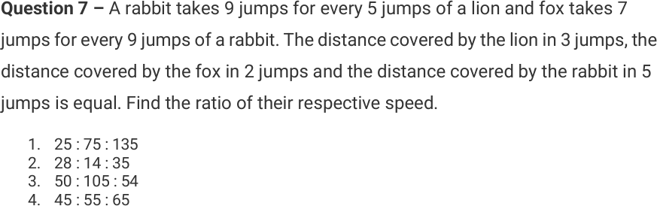

Time and Work

Question 14
Exam: TCS NQT | Difficulty: Basic-Medium

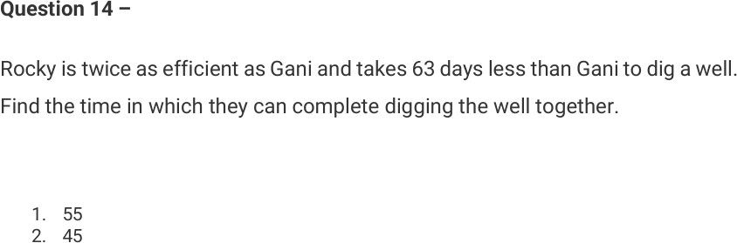

- 42
- 52

Question 14
Exam: TCS NQT | Difficulty: Basic-Medium
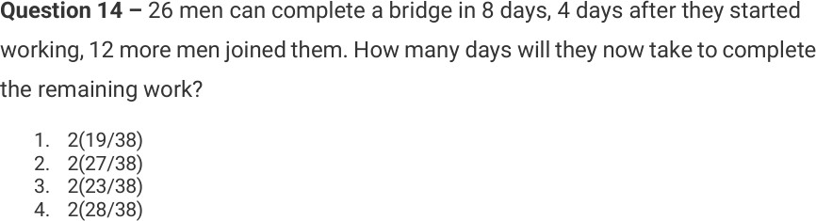

SECTION 3 — MEDIUM

Ages and Ratio

Question 2
Exam: TCS NQT | Difficulty: Medium
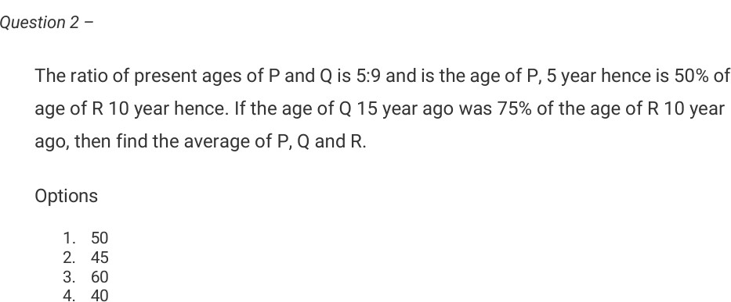

Data Sufficiency

Question 7
Exam: TCS NQT | Difficulty: Medium

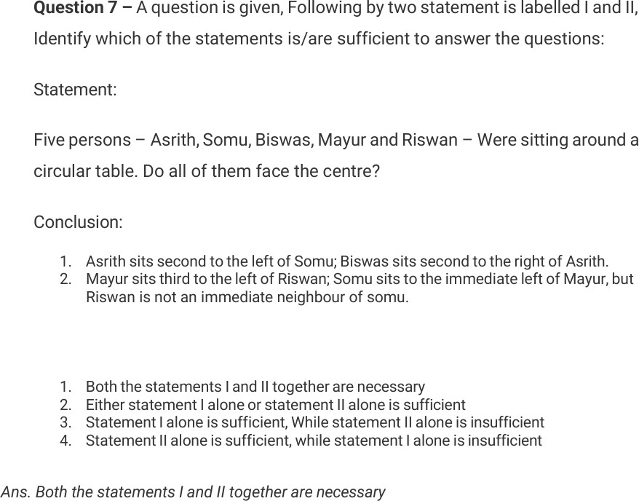

Profit, Commission and Percentage

Question 6
Exam: TCS NQT | Difficulty: Medium
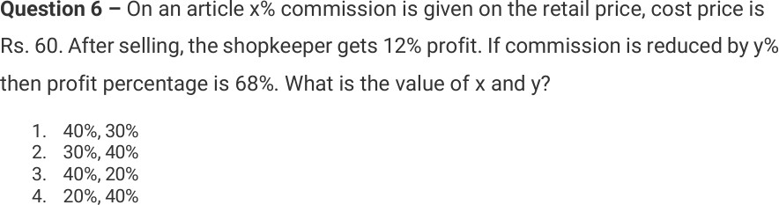

Time and Work

Question 3
Exam: TCS NQT | Difficulty: Medium

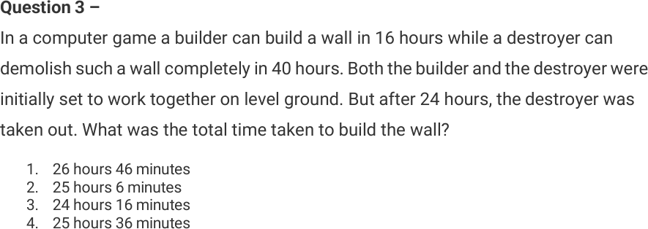

Ratio and Quotation

Question 10
Exam: TCS NQT | Difficulty: Medium
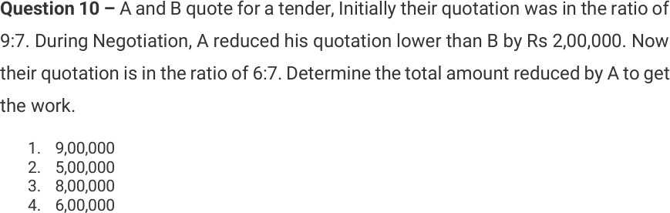

Ratio and Work Distribution

Question 10
Exam: TCS NQT | Difficulty: Medium
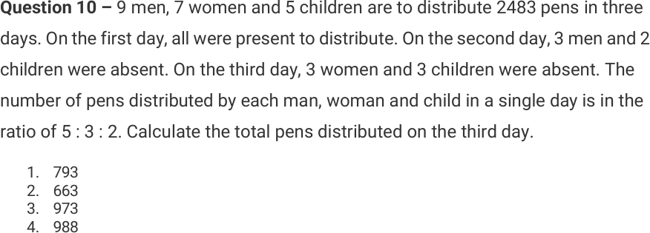

Scheduling

Question 6
Exam: TCS NQT | Difficulty: Medium
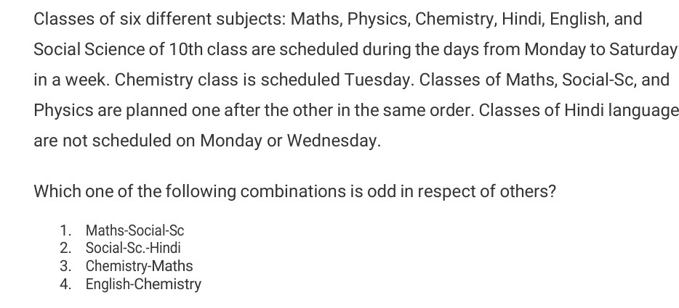

Speed and Distance

Question 15
Exam: TCS NQT | Difficulty: Medium

